Steps for Cleaning Code in HTML Documents
One Suggested Method

- Open the file in the Desire2Learn Editor.
  - Click on the action arrow next to the title and choose Edit HTML.
  - Click inside the editing window.
  - Select all (CTRL + A) then copy the text (CTRL + C).
- Use the HTML-Cleaner to remove outdated code.
  - In a new browser window, go to “HTML-Cleaner (new window).” Be patient, it takes a while to load.
  - Paste the text that you copied from the HTML file into the left window (the source window).
  - Click the Clean HTML button at the lower right side immediately below the HTML window.
Select and copy all of the text in the Source window: Ctrl + A to select all; Ctrl + V to copy.
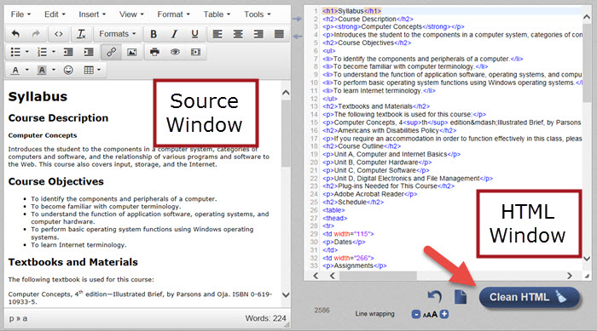
- Go to Desire2Learn to paste the text.
  - Return to D2L and the file where you copied the text.
  - Click on “Select a Document Template” and click on “Browse for a Template.” Choose “Shared Files” at the left then click on the “Styles” folder at the right. Choose the “D2LBasic” folder or “D2LSimple” folder and select a template or select a template that you have uploaded to the Course Offering files. Click the radio button to the left of the desired template file. Click on Add. You will see a blank screen.
  - Click inside the editing window and paste the text you copied from the HTML-Cleaner.
  - Click on Publish.

Optional
If you wish to remove extra spacing from a table, follow these steps:
- From the D2L editing window, select and copy the table from the editing window in D2L.
- Go to the HTML-Cleaner and paste it to the source window.
- Below the HTML window, enter <p> in the “Find” textbox. Click the plus button to add another box and enter </p> in the “Find” box. Leave the “Replace with” boxes blank.
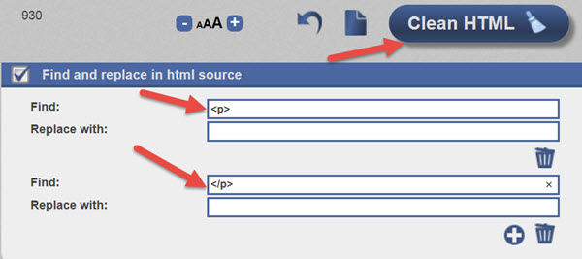
- Click the “Clean HTML.”
- Select the table from the Source window and copy the text. Go to D2L and paste the table at the desired location in the HTML editor.
- Publish.

